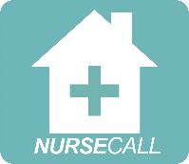
COVID-19 Policy

Original Date of Issue: 07/2020 | Review Date : Annual or continual as per government advice
Author/ Designation: C. Bell/ Partner & Operation Manager | Review author: C Bell 02.2021 (update)  C Bell 07.2021 (update)
Checked by: V. Harris/ Partner & Registered Manager | Review reason: Addition of government and NIPCM advice available

Legislation or regulations referred to:  Additional as of 06.2021: | References:  Massey, 2020. Study Of Italian Town Reveals 40% Of Covid-19 Cases Were Asymptomatic. [online] Uk.news.yahoo.com. Available at: <https://uk.news.yahoo.com/study-italian-town-reveals-more-153228102.html> [Accessed 30 June 2020].  World Health Organisation, 2020. Coronavirus. [online] Who.int. Available at: <https://www.who.int/health-topics/coronavirus#tab=tab_1> [Accessed 30 June 2020].  WHO situation reports dashboard (https://www.who.int/emergencies/diseases/novel-coronavirus-2019/situation-reports)  Johns Hopkins University dashboard (https://coronavirus.jhu.edu/map-faq.html)  SSSC learning hub https://learn.sssc.uk.com/coronavirus/infectioncontrol/  National Infection Prevention and Control Manual (NIPCM)  NHS Education for Scotland (NES) practical COVID-19 units ('Skills Bundles')  The COVID-19: Guidance for Domiciliary Care from Health Protection Scotland  Nipcm.hps.scot.nhs.uk. 2021. National Infection Prevention and Control Manual: Scottish COVID-19 Community Health and Care Settings Infection Prevention and Control Addendum. [online] Available at: <https://www.nipcm.hps.scot.nhs.uk/scottish-covid-19-community-health-and-care-settings-infection-prevention-and-control-addendum/#7.5.2> [Accessed 23 June 2021]. available here
Other Connecting Policies: | Infection Control (Including SICPS)  Health & Welfare
Appendices: | Handwashing Technique (see Infection Control policy)  Hand rub technique (see Infection Control policy)  - COVID-19 Triage Question Checklist  - Emergency/ COVID-19 information sheet
What is Covid-19 (also referred to as Coronavirus)?
In late December 2019 a new (novel) coronavirus was identified in China causing severe respiratory disease including pneumonia. The virus causing the infection was named - severe acute respiratory syndrome coronavirus 2 (SARS-CoV-2) which was a new strain of coronavirus causing COVID-19.
According to the World Health Organisation (WHO) (2020),
“Coronavirus disease (COVID-19) is an infectious disease caused by a newly discovered coronavirus.”
SARS-CoV-2 infections have spread between people globally; see the WHO situation reports dashboard which is updated daily and the Johns Hopkins University dashboard which aims to present real time data uploads. The situation was declared a pandemic on 12th March 2020.

How is it spread?
COVID-19 is spread directly through close contact with an infected person (within two metres) and indirectly through touching a surface, object or the hand of an infected person. Infection prevention and control precautions are of critical importance to reduce the spread of the virus and keep ourselves, as workers, and the people and families we support, safe in their homes.
How people are affected
As a newly identified virus there is currently no human immunity to it, however, since December 2020, in the UK, a vaccine is available to prevent infection. As a viral infection, antibiotics are not an effective treatment.
Most people infected with the COVID-19 virus experienced mild to moderate respiratory illness and recovered without requiring special treatment. However, a vast number of deaths globally, are currently recorded.
Symptoms
NHS have provided the main symptoms shown in people who have contracted COVID-19 https://www.nhs.uk/conditions/coronavirus-covid-19/symptoms/#symptoms as:
- a high temperature – this means you feel hot to touch on your chest or back (you do not need to measure your temperature)
- a new, continuous cough – this means coughing a lot for more than an hour, or 3 or more coughing episodes in 24 hours (if you usually have a cough, it may be worse than usual)
- a loss or change to your sense of smell or taste – this means you've noticed you cannot smell or taste anything, or things smell or taste different to normal

What to advise or do if symptoms develop
Latest NHS advice from https://www.nhs.uk/conditions/coronavirus-covid-19/self-isolation-and-treatment/when-to-self-isolate-and-what-to-do/ state:
Advice as of June 2021:
If someone in your support bubble has symptoms, you will usually need to self-isolate for 10 days. If you test positive, your self-isolation period includes the day your symptoms started (or the day you had the test, if you do not have symptoms) and the next 10 full days.
You may need to self-isolate for longer if you get symptoms while self-isolating or your symptoms do not go away. For up to date advice, use the link above.
Asymptomatic or pre-symptomatic
Pre-symptomatic people are those who are carrying the virus and later go on to develop symptoms, while asymptomatic refers to people who do not show any symptoms at all.
When pre-symptomatic, the incubation period for COVID-19, which is the time between exposure to the virus (becoming infected) and symptom onset according to WHO, is on average 5-6 days, however, can be up to 10 days.
An asymptomatic laboratory-confirmed case is a person infected with COVID-19 who does not develop any symptoms. Asymptomatic transmission refers to transmission of the virus from a person, who does not develop symptoms, therefore infection can occur even when no COVID-19 symptoms are presented. A study of an Italian town revealed more than 40 % of Covid-19 cases were asymptomatic (Massey, 2020).
For this reason, it is vital for all nursing and social care staff to be vigilant and strictly follow the following National Infection Prevention and Control Manual to protect everyone even when no Covid-19 has been confirmed, as set out in the section ‘National Infection Prevention and Control Manual’.
Those most at risk
Any person can contract the virus, however older people, and those with underlying medical problems like cardiovascular disease, diabetes, chronic respiratory disease, and cancer are more likely to develop serious illness, in need of specialist hospital treatment.
Individuals requiring hospital admission

- Clinical or radiological evidence of pneumonia or
- Acute respiratory distress syndrome or
- Influenza like illness (fever ≥37.8°C and at least one of the following respiratory symptoms, which must be of acute onset:
- persistent cough (with or without sputum), hoarseness, nasal discharge or congestion, shortness of breath, sore throat, wheezing, sneezing)or
- A loss of, or change in, normal sense of taste or smell (anosmia) in isolation or in combination with any other symptoms.
Health Protection Scotland Clinicians should be alert to the possibility of atypical and non-specific presentations in older people with frailty, those with pre-existing conditions and patients who are immunocompromised.
Sheilding and Risk Assessment
Nurse Call acknowledges that many of the people we support, either in their own home or in our agency setting, may be in the shielding category and should be risk assessed into medium or high risk. Such information can be found in a clients Emergency/ covid-19 information sheet (see appendix ii).
The National Infection Prevention and Control Manual: Scottish COVID-19 Community Health and Care Settings Infection Prevention and Control Addendum recommendation, (June 2021):
Risk categories must be established to ensure segregation of individuals determined by their risk of COVID-19.
Any other known or suspected infections and the need for any Aerosol Generating Procedures (AGPs) must be considered before individual placement within each of the category areas.
Establishing which category an individual is in will determine Personal Protective Equipment (PPE) and decontamination requirements.
Any services providing care at home should phone ahead to the individual prior to a visit and ask the triage questions in (COVID-19-triage-checklist_(V1) CB 06.21 or appendix i) to determine what category they will be on wherever possible. If difficulty in phoning due to cognitive impairment or disturbing a household not within waking hours, this assessment may take place prior to entering the home, 2 metres from the doorway and documented in care notes as assessed.
Within Acute care settings there is an additional low risk pathway which can be found in the Scottish Acute Care COVID-19 Addendum however it is expected that all individuals in community and care at home settings will fall into the Medium or High risk categories. Guidance beyond this section will only refer to the medium and high risk categories.
1. Known as the High Risk COVID-19 risk category in the UK IPC remobilisation guidance and is more commonly known as the red risk category.
- Confirmed COVID-19 patients/individuals.
- Symptomatic or suspected COVID-19 patients/individuals (as determined by hospital or community case definition or clinical assessment where there is a suspicion of COVID-19 taking into account atypical and non-specific presentations in older people with frailty those with pre-existing conditions and patients who are immunocompromised).
- Those who are known to have had contact with a confirmed COVID-19 individual and are still within the 14-day self-isolation period and those who have been tested and results are still awaited.
- Individuals who are symptomatic or suspected COVID-19 but who decline testing or who are unable to be tested for any reason.
2. Known as the Medium Risk COVID-19 risk category in the UK IPC remobilisation guidance and may be commonly known as the amber risk category.
- All other patients/individuals who do not meet the criteria for the pathways above and who do not have any symptoms of COVID-19.
- Asymptomatic patients/individuals who refuse testing or for whom testing cannot be undertaken for any reason.
- Those who are asymptomatic have been tested and results are still awaited.
- Recovered COVID-19 patients/individuals.
Some individuals who no longer require medical care in hospital will be discharged home or to their long-term care facility to fully recover. These people may not have completed their isolation period and can be safely cared for at home if this guidance is followed. The acute should provide information regarding test results and a plan for stepping down IPC measures on discharge.

Care at Home setting only
Triage and individual Risk Assessment pre-Care at Home visit (see appendix i)
The following is a collaboration between both NIPCM advice and Scottish Government advice link (last updated 21st May 2021)
All efforts should be made to establish which COVID-19 category the individual is in before arrival at an individual’s home using Nurse Calls ‘COVID-19 Triage checklist-individual Risk Assessment form’ (see appendix ii). Establish whether or not the individual has any new presenting symptoms or risks involved.
An FRSM should be worn on entering an individual’s home. On arrival, assess the activities and tasks to be undertaken. If possible, they should be performed in such a way that 2 metre physical distancing is maintained. Where 2 metre physical distancing cannot be maintained, PPE should be worn in line with the below table. Donning and doffing of PPE in the care at home settings is covered in Staff training section which is completed by all staff.
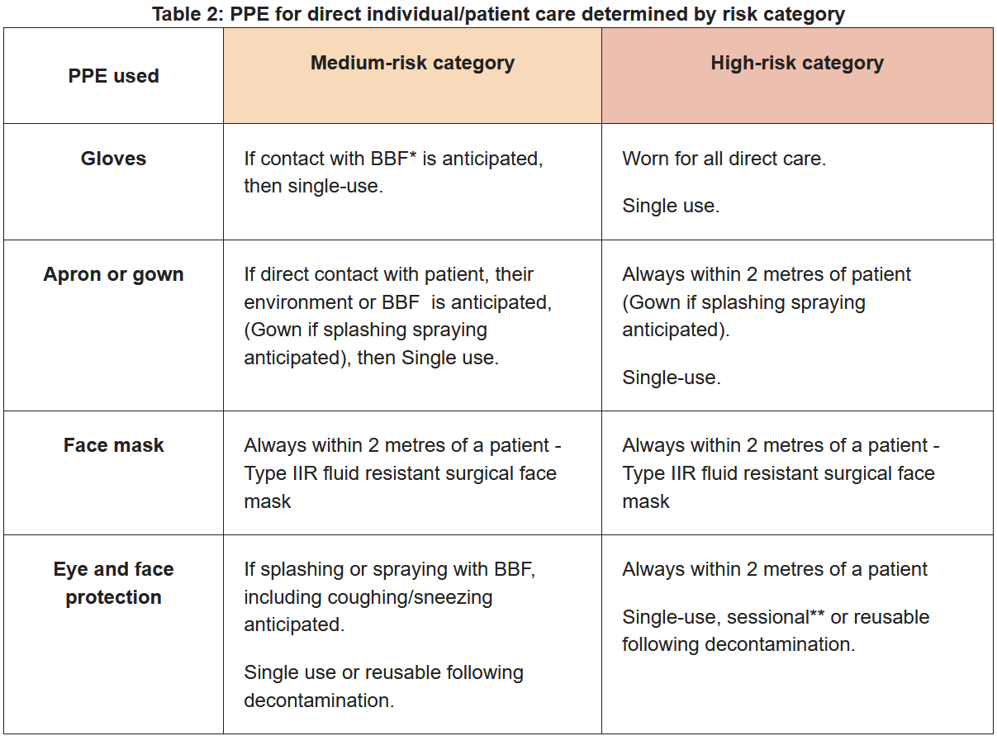

Care at Home and Nurse Agency
Shielding is a measure to protect those at very high risk of severe illness by minimising all interaction between them and others, resulting in a lesser chance of contracting the virus. This will involve following the latest shielding guidelines as set by Scottish government at the time. These details are found at: https://www.gov.scot/publications/covid-shielding/
Typically shielding involves
- stay at home as much as they can
- avoid going places that are indoors
- only leave their home to be active or meet with people from another household outdoors
- keep 2 metres away from everyone, even those they live with
Lockdown measures
Lockdown means: urgent action to bring Coronavirus under control.
Nurse Call and all staff members must remain vigilant of new guidelines and laws affecting Mainland Scotland and understand that new legal requirements can be in place forbidding anyone from leaving their home except for essential purposes.
Further and current advice on this can be located here https://www.gov.scot/news/scotland-in-lockdown/
If staff are found to be in breech of any laws set out by Scottish government, immediate disciplinary action will be taken, including the possibility of dismissal.
Lockdown Level categories
There are 5 COVID-19 Protection Levels (0-4). The rules we must follow depend on the level for your council area are available at https://www.gov.scot/publications/coronavirus-covid-19-protection-levels/.
A general overview as of June 2021:
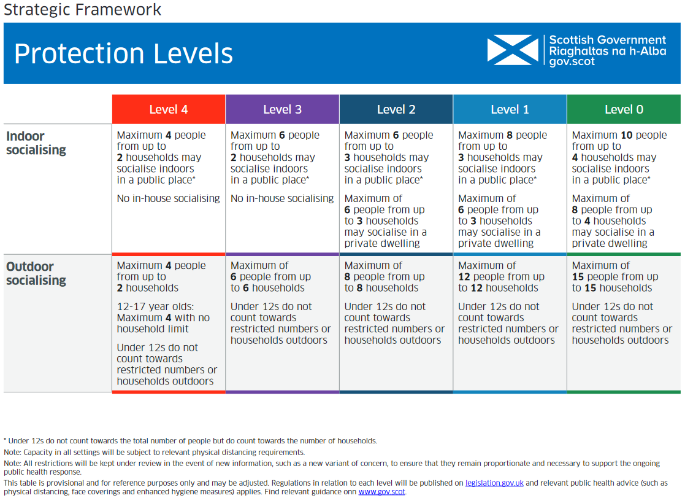
At time of policy update 07.21, Scottish government declared: All of Scotland is at Level 0.
All major COVID-19 restrictions will be lifted on 9 August 21 if the necessary conditions on vaccination and harm reduction continue.
Our Strategic Framework update (June 2021) sets out what a move beyond Level 0 may look like. Nurse Call must continue with all PPE and COVID-19 precautions until they hear otherwise.
Our staff at risk
Nurse Call staff are also at greater risk due to their frontline approach and must follow this policy to protect themselves and those they are in a position to care for. This policy further explains how to protect staff and residents. However, if staff personally have any of the underlying shielding conditions mentioned above, have been notified by the NHS to shield themselves, develop symptoms or recognise the symptoms in their own household or in someone they care for, they are to contact Nurse Call management immediately by means of telephone. Nurse Call management will perform a ‘COVID-19 risk assessment’, taken from the Care Inspectorate and be able to further advise on an individualised approach.
All staff have availability via Nurse Call, to the Scottish Government and Health Protection Scotland’s ‘Test and Protect programme’. All staff may be asked or wish to take a COVID-19 test even if they have no symptoms. The testing aims to reduce transmission and protect vulnerable people receiving care, available here https://news.sssc.uk.com/news/testing-for-covid-19-in-social-services.
Weekly testing of staff
All Nursing Agency staff must book and undergo weekly COVID-19 testing for the purpose of protecting Service Users and Staff in the places they work. Nurse Call has registered and notified all staff for this service and keeps a paper record of all testing.
Nurse Call recognise that the booking of these tests had previously been problematic, unless staff had symptoms prior to December 20, but newly have access if selecting ‘I have been asked to book a test’, therefore all staff will be required to produce verification of weekly testing- negative to enable shift booking as an agency worker. Care at Home workers also have been advised to test.
Lateral Flow Test (LFT)
Lateral flow antigen tests work by taking a sample from the nose or back of the throat and testing that sample for the presence of antigens, the signature proteins of the virus. They show results visually within 30 minutes.
Nurse Call have acquired via registration locally and disseminated supplies of LFTs to all staff and will continue the rolling out of these. As per instructions from our NHS community hub, Nurse Call have recommended staff use these twice weekly, prior to attending their shift/s and have a professional responsibility to inform Nurse Call of any positive results.
COVID-19 Vaccinations for staff
Nurse Call have registered all staff for the vaccination programme. All staff have received both 1st and 2nd vaccines (06.21).
Test & Protect for staff members (7 day testing, if deemed appropriate)
To further protect our service users, care homes and staff members, Nurse Call will be within their rights to request proof every 7 days of any staff members Covid-19 status if they deem this to be in the Public Health’s interest. Staff will be able to access this personally at https://www.gov.uk/apply-coronavirus-test-essential-workers and should approach managers if they incur any issues accessing this testing. This should identify any positive cases in a timeously and evoke a culture of trust in providing our services. Proof of status should be e-mailed to: info@nurse-call.co.uk.
Our service users and any care homes we provide services for, will be able to access this information by asking the staff member directly for such proof within 2 hours of the start of the shift (we recommend this be prior to the start of the shift). If this proof cannot be provided when requested, they will be asked to isolate the staff member and contact Nurse Call On Call: 077 420 406 77 to notify of a subsequent staff member being required. The isolated staff member may be sent home without pay for the entire contracted shift.
Test and Protect, Employers responsibilities and staff compliance
Test and Protect, Scotland’s approach to implementing the 'test, trace, isolate, support' strategy is a public health measure designed to break chains of transmission of Coronavirus (COVID-19) in the community. Further information can be located from gov.scot here
The Scottish Government and the Scottish Trades Union Congress (STUC) made a joint statement on fair work expectations at the start of the pandemic, which still applies now: it said that no worker should be financially penalised by their employer for following medical advice, and any absence from work relating to COVID-19 should not affect future sick pay entitlement, result in disciplinary action or count towards any future sickness absence related action. This statement applies to workers who are sick or self-isolating under the Test and Protect strategy.
The NHS will test people who have symptoms, trace people who may have become infected by spending time in close contact with someone who tests positive, and then support those close contacts to self-isolate. That means if they have the virus they are less likely to pass it on to others. Employers will play a vital role in ensuring that their employees are aware of and able to follow the public
Staff who have recovered from COVID-19

Staff with confirmed/suspected COVID-19 should not return to work until symptoms resolve and isolation complete (as per Scottish Government advice at the time), with the exception of cough and loss of/ change in taste and smell, as these symptoms may persist for several weeks and is not an indication of ongoing infection when other symptoms have resolved. Staff should only return to work when they are feeling clinically better, have been afebrile for 48 hours without the use of anti-pyretics and have completed their self-isolation period. Staff who have had confirmed COVID-19 and have since recovered must continue to follow the IPC measures as for all other staff including PPE.
Organisations and employers should monitor staff health and advise on any health and support needs.

What Nurse Call management will do

Nurse Call will follow public health guidance if an employee becomes unwell with coronavirus symptoms at work. The person should leave work to self-isolate straight away and, if possible, wear a face covering on route and avoid public transport. Nurse Call will direct workers to www.nhsinform.scot or, if they can’t get online, call 0800 028 2816, to arrange to get tested.
Until they have been tested and told if it is safe to leave home, Nurse Call should make sure that staff do not have to, or feel that they have to, come into work. Employees can request an isolation note through NHS Inform.
NHS contact tracers will interview them and get in touch with people they have been in close contact with and tell them they must self-isolate for 10 days (or as per Scottish government advice at the time). Nurse Call will keep in contact by telephone with the worker to ensure their well-being and assist wherever possible.
Nurse Call management will assist the NHS contact tracers to ensure the least possible impact from the virus and support other workers, care facilities and service users, as appropriate.
Nurse Call measuring staff and the service they provide during COVID-19

Nurse Call management responsibilities are to ensure both their staff and Clients are as safe and well as possible and reduce the risks to both. Management is responsible for ensuring that the Care Inspectorate Key Quality 7 is measured by means of evaluating the service utilising the tool. From this they can determine ways to improve.

In addition, Nurse Call management will regularly perform audits:

Care at Home
Telephone the Client prior to visiting or staff assessing and measuring risk of the Client for COVID-19 symptoms OR prior to entering the home if deemed more appropriate.
In addition to this, staff will be required to continually assess during the visit and enter this into daily notes:

Nurse Agency
Staff Training
A crucial step to lessening risk to both Nurse Call staff and our service users will be in the mandatory training which encompasses both Care at Home and the agency setting. All staff will also be required to read and understand this, and our infection control (based on NIPCM) policy.
Our two identified learning sites will be accessed at the following links:
- NHS Education for Scotland (NES) practical COVID-19 units ('Skills Bundles') for health and social care workers and many other resources on a dedicated TURAS Learn page (staff to contact Nurse Call management if any access issues).

- The COVID-19: Guidance for Domiciliary Care from Health Protection Scotland which supports those working in domiciliary care settings and gives staff and users of their services advice about COVID-19. This includes staff who support and deliver care to people in their own homes (including supported living settings).

- Donning and Doffing online video: https://vimeo.com/393951705
https://deref-mail.com/mail/client/4tlmh8KIObs/dereferrer/?redirectUrl=https%3A%2F%2Fvimeo.com%2F393951705

Staff can find further information at:
The SSSC weblink, COVID-19 guides on their Learning Zone.

Workforce education information

Further educational resources from NHS Education Scotland (NES) which all Nurse Call staff have accounts for:
The Turas Learn website has a range of NES educational and induction resources for all health and social care staff and volunteers deployed to support clinical services. Requirements are under constant review and additional resources will be added as required.

Hand Hygiene educational resources
As a reminder to infection control induction training, the following hand hygiene short films are available on Vimeo and are existing NES resources. They demonstrate the:
- correct use of alcohol-based hand rub (ABHR)
- correct hand hygiene technique using soap and water

Infection Control during COVID-19

(includes both Care at Home and Nurse Agency settings, unless otherwise specified)
This must be used in conjunction with Nurse Calls existing Infection Control Policy during such time the Scottish Government says otherwise with particular attention to Transmission Based Precautions (TBPs). Information specific to Covid-19 is collated and updated and continually reviewed on:
- Care at Home setting Nipcm.hps.scot.nhs.uk. 2021. National Infection Prevention and Control Manual: Scottish COVID-19 Community Health and Care Settings Infection Prevention and Control Addendum. [online] Available at: <https://www.nipcm.hps.scot.nhs.uk/scottish-covid-19-community-health-and-care-settings-infection-prevention-and-control-addendum/#7.5.2> [Accessed 23 June 2021]. available here

Nurse Agency setting Scottish COVID-19 Infection Prevention and Control Addendum for Acute Settings. Available: https://www.nipcm.scot.nhs.uk/scottish-covid-19-infection-prevention-and-control-addendum-for-acute-settings/
- The National Infection Prevention and Control Manual (NIPCM) for Scotland which is for all those involved in care provision in any setting, including care at home. It aims to ensure the safety of those being cared for, staff and others in the care setting. It sets out Standard Infection Control Precautions (SICPs) and Transmission Based Precautions (TBPs).

- The NIPCM directs employers to further utilise information set by Health Protection Scotland https://www.hps.scot.nhs.uk/a-to-z-of-topics/covid-19/ on up to date COVID-19 guidance.
Physical distancing measures should be followed by everyone, including children, in line with the government advice to stay at home and away from others (physical distancing). The aim of physical distancing measures is to reduce the transmission of COVID-19. Up to date information can be found on the NHS Inform website. Note that shielding advice should be followed by individuals at risk of severe infection.
Physical distancing by staff of 2 metres should be followed wherever this is possible. This includes all staff adhering to physical distancing (2 metres) wherever possible, particularly if not wearing a facemask or visor and when in non-clinical areas. Review practice to consider staggering staff breaks to limit the density of healthcare workers in specific areas.

Nurse Agency (Care Home) Setting
Testing for Covid-19
When Nurse Call Staff are in a Care Home setting, they should consult the manager, person in charge or local policy for what to do. However, Health Protection (HPT) state that:

If an outbreak of COVID-19 is suspected within the care home, then the local HPT should be contacted. An outbreak is NORMALLY defined as two linked cases of a disease. For care homes specifically, with respect to COVID-19, an outbreak should be suspected when there is a single new case with symptoms consistent with COVID-19 infection arising in the care home, likely to be due to spread of the virus within the care home.

Assessment of resident cases when considering any potential outbreak should also include symptomatic cases who have either been transferred from the facility to hospital as a result of infection or a suspected COVID-19 individual who has died within the same time period.

A control measure tool for the control of incidents and outbreaks in Social or Community Care & Residential Settings, specific for COVID-19, is available here .

For advice on for testing of residents and staff as well as other IPC measures to help limit further spread of the virus and control the outbreak contact the local HPT :

Greater Glasgow & Clyde 0141 201 4917/ Gartnavel switchboard 0141 211 3600

All care home residents who develop any symptoms suggesting possible COVID-19 infection should be clinically assessed.

If the clinical assessment confirms that their symptoms or clinical condition suggest COVID-19 infection, then urgent testing should be carried out of the entire care home, including all care home residents and all staff, including those present on shift and all others not then currently on shift.

Irrespective of the presence or absence of symptoms, all others should be tested (subject to consent and clinical practicality). If however, the clinical assessment on the initial case is not consistent with COVID-19 infection, given the possibility of atypical COVID clinical presentations, a COVID-19 PCR test should still be carried out to exclude COVID-19 infection.

In such a case, the decision on testing all others in the care home could await the test result on that individual, providing there is no undue delay in receipt of the result. If their PCR test result is positive, then as before, the entire care home including all residents and all staff should then be tested urgently.
Health Protection Scotland may also wish to sample test in care homes where there are no cases. By definition this will also include testing residents and staff who are not symptomatic.

Care at Home Setting
Testing for Covid-19
No clear guidance is found for a Care at Home setting at the time of writing by HPS, however, the above Care Home setting can be utilised with caution to not spread the infection, utilising a clinical approach.
Any staff member or service user who may be presenting with symptoms, should contact the Nurse Call manager by telephone immediately on 0141 639 1802 (on Call 077 420 406 77) who will:
- Utilise the Social or Community Care & Residential Settings TOOL, specific for COVID-19, available here.
- The manager should also discuss their findings by telephone with the Service Users GP or NHS24 (out of hours) for further guidance and to notify under Public Health (Scotland) Act 2008.
- Unless already designated by the GP/NHS 24, the manager should consult the Health Protection Team (HPT) via telephone on 0141 201 4917/ Gartnavel switchboard 0141 211 3600.
Staff use of Personal Protective Equipment (PPE)

Care at Home and Care Homes Settings

In addition to complying with Nurse Calls Infection Control Policy with regards to the use of PPE, during COVID-19, or when dealing with a suspected or confirmed case of COVID-19, further measures are required.

The following table (also available here) as recommended by HPS shows the enhanced measures Nurse Call will take unless a contingency assessment states otherwise:

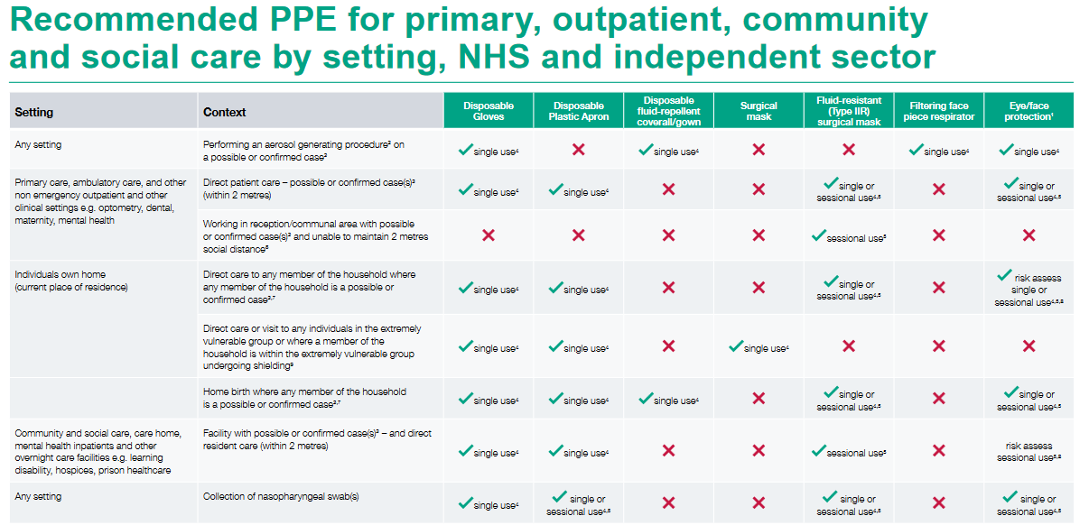

Explanation and clarification on table:

1. This may be single or reusable face/eye protection/full face visor or goggles.

2. The list of aerosol generating procedures (AGPs) is included in section 8.1 at: www.gov.uk/government/publications/wuhan-novel-coronavirus-infection-prevention-and-control/covid-19-personal-protective-equipment-ppe. (Note APGs are undergoing a further review at present)

3. A case is any individual meeting case definition for a possible or confirmed case: https://www.gov.uk/government/publications/wuhan-novel-coronavirus-initial-investigation-of-possible-cases/investigation-and-initial-clinical-management-of-possible-cases-of-wuhan-novel-coronavirus-wn-cov-infection

4. Single use refers to disposal of PPE or decontamination of reusable items e.g. eye protection or respirator, after each patient and/or following completion of a procedure, task, or session; dispose or decontaminate reusable items after each patient contact as per Standard Infection Control Precautions (SICPs).

5. A single session refers to a period of time where a health care worker is undertaking duties in a specific care setting/exposure environment e.g. on a ward round; providing ongoing care for inpatients. A session ends when the health care worker leaves the care setting/exposure environment.Sessional use should always be risk assessed and considered where there are high rates of hospital cases. PPE should be disposed of after each session or earlier if damaged, soiled, or uncomfortable.

6. Non clinical staff should maintain 2m social distancing, through marking out a controlled distance; sessional use should always be risk assessed and considered where there are high rates of community cases.

7. Initial risk assessment should take place by phone prior to entering the premises or at 2 metres social distance before entering; where the health or social care worker assesses that an individual is symptomatic with suspected/confirmed cases appropriate PPE should be put on prior to providing care.

8. Risk assessed use refers to utilising PPE when there is an anticipated/likely risk of contamination with splashes, droplets or blood or body fluids.

9. For explanation of shielding and definition of extremely vulnerable groups see guidance: https://www.gov.uk/government/publications/guidance-on-shielding-and-protecting-extremely-vulnerable-persons-from-covid-19/guidance-on-shielding-and-protecting-extremely-vulnerable-persons-from-covid-19

Providing PPE

Nurse Call will provide the appropriate PPE to all staff relevant to the individual situation. Any individual case variation to the condition of a service user should be reported to management immediately to ensure the appropriate PPE is provided.

Aerosol Generating Procedures

The list of aerosol generating procedures (AGPs), a procedure that is deemed at high risk for spreading the virus and therefore requiring more protection is included in section 8.1 at: www.gov.uk/government/publications/wuhan-novel-coronavirus-infection-prevention-and-control/covid-19-personal-protective-equipment-ppe. (Note APGs are undergoing a further review at present)

The following procedures are considered likely to generate aerosols capable of transmitting respiratory pathogens when undertaken on patients with an RTI:

intubation, extubation and related procedures; for example, manual ventilation and open suctioning
- cardiopulmonary resuscitation
- bronchoscopy (unless carried out through a closed-circuit ventilation system)
- surgery and post-mortem procedures in which high-speed devices are used
- dental procedures
- non-invasive ventilation (NIV) e.g. bilevel positive airway pressure ventilation (BiPAP)
- continuous positive airway pressure ventilation (CPAP)
- high frequency oscillatory ventilation (HFOV)
- induction of sputum

Certain other procedures/equipment may generate an aerosol from material other than patients’ secretions but are NOT considered to represent a significant infectious risk. Procedures in this category include:
- obtaining diagnostic nose and throat swabs
- administration of pressurised humidified oxygen
- administration of medication via nebulisation

During nebulisation, the aerosol derives from a non-patient source (the fluid in the nebuliser chamber) and does not carry patient-derived viral particles. If a particle in the aerosol coalesces with a contaminated mucous membrane, it will cease to be airborne and therefore will not be part of an aerosol. Staff should use appropriate hand hygiene when helping patients to remove nebulisers and/or oxygen masks.

For patients with possible or confirmed COVID-19, any of these potentially infectious AGPs should only be carried out when essential. Where possible, these procedures should be carried out in a single room with the doors shut. Only those healthcare staff who are needed to undertake the procedure should be present.
PPE in Resuscitation
Chest compressions and defibrillation (as part of resuscitation) are not considered AGPs; first responders (any setting) can commence chest compressions and defibrillation without the need for AGP PPE while awaiting the arrival of other clinicians to undertake airway manoeuvres.
Based on the NERVTAG evidence review and consensus statement, chest compressions will not be added to the list of AGPs. Nurse Call does advise their clinical staff to wear FFP3 respirators, gowns, eye protection and gloves when performing chest compressions when available but it does strongly advised that there is no potential delay in delivering this life saving intervention.

PPE Posters from HPS
To provide absolute clarity on what the revised PPE changes mean for health and social care staff working on the frontline, HPS has produced visual posters specifying what kind of PPE should be worn in which setting or scenario

Posters used by Nurse Call in Scotland, can be located for print/ reference at https://scottishcare.org/ppe-posters-from-health-protection-scotland/

All posters are on display in Nurse Call base for staff to view and should also be available to refer to, in all Care Home settings, as provided by the individual Care Home local and government Policy. If any staff find this information lacking on placement, they are asked to inform Nurse Call staff who can assist.

Care at Home Setting

Care Inspectorate advice when people share their own home

Staff supporting people in their own homes should follow good infection control guidance and Health Protection Scotland guidance. Where people share a home, the provider should advise that when washing their hands, they use liquid soap or not to share a bar of soap, use a paper hand towel or have their own towel and not use shared hand towels. Using bathrooms and other shared facilities at different times can also reduce the risk of spreading infection, ensuring that the area is cleaned after each use. If one person in the house self isolates, then all members of the house should self-isolate in line with government guidance. If people are advised to self-isolate, further guidance on possible COVID-19 symptoms can be found in the above section: Symptoms.
Keeping the working environment clean to prevent infection during a suspected or confirmed COVID-19 case

Care Home (Nurse Agency)

Nurse Call staff should follow the guidance from the placement they are contracted to. Further details can be found here

Care at Home Setting only
When to wear a mask
(Scottish Government advice 6th Aug 2021)
As there is still at present ongoing community transmission, it is recommended that staff providing direct care to individuals in the following settings should wear a Fluid Resistant (Type IIR) Surgical Mask (FRSM) at all times throughout their shift. This includes wider community care (including adult social or community care, adult residential and care home settings and domiciliary care. All guidance in relation to mask wearing is constantly reviewed and the National Infection Prevention and Control Manual: Scottish COVID-19 Community Health and Care Settings Infection Prevention and Control Addendum will be updated pending any changes to guidance.

Changes to face masks wearing policy as we progress throughout the pandemic
The extended use of face masks for staff is a remit for Scottish Government. If the current practice were to change there would be guidance issued on this.
When worn correctly, face masks can provide protection to those around the wearer from droplet and aerosol transmission and they can also provide some protection to the wearer. They also serve a purpose in source control by reducing contamination to the environment surrounding the wearer. Face masks are one method of control and should not be a substitute for physical distancing, respiratory and hand hygiene and enhanced ventilation in indoor spaces, which all remain important.

Wearing face masks when visiting different clients (sessional use)
The advice ARHAI give is to remove face mask (along with other PPE if worn) at the end of each visit and put in a disposal bag then a bin bag and tie before leaving the person's home, where there is a safe place to do so (e.g. in a porch). We advise not to leave PPE on including face masks, out with the home or to the next visit. If there is no safe place to take PPE off before leaving the home, we advise that PPE including the face mask, is removed immediately on leaving home and placed in disposal bag and disposed of as local arrangements.

Face masks use for clients
Individuals receiving Nurse Call care are not required to wear a face mask/covering in their own home. However, if you are going to deliver care within 2 metres, it would be reasonable to ask your client, to put on a face covering where it can be tolerated, during the care activity. However, they are not obligated to do so. As a care professional you should be wearing an FRSM mask and as this will provide both protection to the wearer and client and provide source control. Therefore, the focus should be on ensuring you are correctly wearing your FRSM mask and appropriate level of PPE for the task.
We encourage care at home staff to discuss mask wearing with clients prior to attending the clients’ home.
As a care professional you should be wearing an FRSM mask and this will provide both protection to the wearer and client and provide source control.

Wearing face masks in public places with clients
Care at home staff and their clients should adhere to Scottish Government guidance and legislative requirements on face covering use in public spaces. We have made face coverings mandatory in most indoor public places, indoor communal spaces including retail, restaurants, cafes, bars and public houses, and in workplaces and on public transport. People must wear a face covering unless they are exempt from doing so because of specific circumstances.

Providing care and use of facemasks when clients have visitors in their homes
Under the Scottish Government levels guidance, where visitors are allowed in private homes, they are not required to wear face coverings. Therefore, you may attend a house where a client has family/friends in attendance. In these instances, as per the Scottish Government level guidance they do not need to wear a face mask or face covering, however as a care professional for nurse Call, you must continue to wear your face mask.
Additionally, if there are visitors in someone’s home, it would not be unreasonable that you ask they go into another room, whilst you deliver any care.
It may also be appropriate to ask that a window is opened in the room you will be providing care before you attend and during your time with the client to increase ventilation.
We encourage all social care professionals to discuss measures that can be taken to support care in a safe way with their clients and where appropriate clients delegated representative.

Care at Home and Nurse Agency (Care home) setting
The use of appropriate PPE
Nurse Call staff should follow Nurse Calls existing Infection Prevention and Control Policy. In addition, should follow Health Protections advice as below:
PPE (following PPE Posters from HPS)
All staff are trained in how to put on and remove PPE safely.
Putting on PPE

Before putting on PPE:

•Check what the required PPE is for the task/visit
•Select the correct size of PPE
•Perform hand hygiene

PPE should be put on before entering the room.

•The order for putting on is apron, surgical mask, eye protection (where required) and gloves.
•When putting on mask, if straps used: position the upper straps on the crown of head and the lower strap at the nape of the neck. Mould the metal strap over the bridge of the nose using both hands.

The order given above is a practical one; the order for putting on is less critical than the order of removal given below.

When wearing PPE:

•Keep hands away from face and PPE being worn.
•Change gloves when torn or heavily contaminated.
•Limit surfaces touched in the care environment.
•Always clean hands after removing gloves

Removal of PPE

PPE should be removed in an order that minimises the potential for cross-contamination.

Gloves

•Grasp the outside of the glove with the opposite gloved hand; peel off.
•Hold the removed glove in gloved hand.
•Slide the fingers of the un-gloved hand under the remaining glove at the wrist.
•Peel the glove off and discard appropriately.

Gown

•Unfasten or break ties.
•Pull gown away from the neck and shoulders, touching the inside of the gown only.
•Turn the gown inside out, fold or roll into a bundle and discard.

Eye Protection

•To remove, handle by headband or earpieces and discard appropriately.

Fluid Resistant Surgical facemask

•Remove after leaving care area.
•Untie or break bottom ties, followed by top ties or elastic and remove by handling the ties only (as front of mask may be contaminated) and discard as clinical waste.
•For face masks with elastic, stretch both the elastic ear loops wide to remove and lean forward slightly. Discard as clinical waste.

To minimise cross-contamination, the order outlined above should be applied even if not all items of PPE have been used.

Perform hand hygiene immediately after removing all PPE.

PPE should be put on in a safe area either inside the premise, such as a porch or a separate room, if there is no available area then the mask can be put on immediately prior to entering the home, and gloves and apron when in the home.

PPE should be removed before leaving the home or care setting and should not be worn out with the homes or to the next visit. If caring for more than one individual in the same house, then a mask/eye protection only can be considered sessional use until completion of the tasks/care. Hand hygiene must be carried on immediately after removing PPE, PPE should be disposed as detailed below:

Waste

Whilst in the home any waste generated due to personal care (including PPE) should be bagged as normal. If the person has COVID-19 this should be double bagged and held in the home for 72 hours before disposal into the normal household waste stream for collection. The bag should be marked for storage for 72 hours (add date and time to the bag). If the household/ individual has a special waste uplift for personal care items, PPE should be bagged and placed in the receptacle.

Staff should avoid visiting individuals who are on CPAP or BiPAP at home as these are considered aerosol generating procedures–see list of AGPs above in Aerosol Generating Procedures. Phone consultations or assessment before entering the premises using Nurse Call COVID-19 triage checklist in the first instance to assess whether the individual requires a home visit. If it is safe to postpone the visit until symptoms have resolved or to activate the agreed Covid contingency plan, then do so.

If a home visit cannot be avoided;

•Find out what time the individual is on CPAP/BiPAP and plan to visit for at least an hour or more after the CPAP or BiPAP has been switched off

•Ask the individual to move to another room in the property and close the door to the room where the CPAP or BiPAP is undertaken.
•If the visit must take place when the patient is on the CPAP/BiPAP or if the above measures cannot be followed, the member of staff must wear AGP PPE in line with https://assets.publishing.service.gov.uk/government/uploads/system/uploads/attachment_data/file/878750/T2_poster_Recommended_PPE_for_primary__outpatient__community_and_social_care_by_setting.pdf and https://assets.publishing.service.gov.uk/government/uploads/system/uploads/attachment_data/file/879111/T4_poster_Recommended_PPE_additional_considerations_of_COVID-19.pdf whilst performing an AGP. It is the responsibility of Nurse Call to ensure that all staff have been fit tested for FFP3 respirators where appropriate.

Access to personal protective equipment (PPE) and other equipment

Nurse Call are registered with the Care Inspectorate as they are providing health and care support and if they have an urgent need for PPE after having fully explored local supply routes/discussions with NHS Board colleagues, can contact a triage centre run by NHS National Services for Scotland (NHS NSS). Nurse Call currently collects difficult to source PPE from its local NHS hub: Eastwood Health & Care Centre.

Nurse Call has a good supply of all PPE, disposable bags, blue roll for drying hands, labels for bags and disinfectant wipes which staff can collect from Nurse Call base at any time for work purposes, or arrange via Nurse Call base on 0141 639 1802 for this to be provided at a Clients home prior to entering their home.

Care at Home Setting only

Providing care to individuals in their own home

Physical distancing and staying safe guidance is in place for everyone. Stringent physical distancing is recommended for a sub-group of the general public following physical distancing. This includes those over 70, pregnant and those with specific chronic conditions but not those in the shielding category. This group is at increased risk of disease, but the risk is not as high as those following shielding advice. A large proportion of people receiving care will come into this category. No additional measures are required for this group of people, as the appropriate measures are the same as for all other patients in accordance with Nurse Calls existing Infection Prevention and Control Policy.

Providing care to individuals who are shielding in their own home

Nurse Call should identify individuals in this category and should assess the individuals needs and allocate dedicated staff (if possible) to care for those in the shielding groups. This should be reviewed regularly to ensure it is up to date. Allocate other staff members to consistently care for the needs of those not in the shielding category. During the pandemic it is important to minimise the visits to those individuals in the shielding category and if possible, the number of staff undertaking the visit. The person receiving care may make the decision to suspend some of the care or for this to be provided by a carer or guardian. This should be discussed by management within Nurse Call and a reduction in contracted hours be considered to reflect the safest option for the Service User. Where it is not possible to allocate specific staff to care for individuals shielding groups, it may be possible to schedule visits to shielding patients before visits to others.

Assessing Service Users for Covid-19 Symptoms or those who have been contacted by HPS via Test and Protect.

All staff visiting a Service User has to document at every visit for Covid-19 status. They should clearly document and report to management of any change noted. Management will assess and advise both the staff member and Service User of any requirements as recommended by NHS inform, HPS and NIPCM guidelines.

Providing care to someone who develops symptoms of COVID-19

If anyone being cared for by a home care provider reports developing COVID-19 symptoms they should be advised to visit the NHS Inform website to arrange testing. If the individual or home care provider is unable to access the website, then call NHS24 free on 0800 028 2816 or NHS 111. If the individual is unwell and requires clinical assessment then seek advice on NHS Inform and contact NHS 111 via telephone, or online. If they are unable to call NHS 111 themselves then the home care provider should call on their behalf. In an emergency, they should dial 999.

As part of the “Test and Protect” approach, everyone with symptoms is encouraged to get tested. Tests can be booked through NHS Inform or by calling NHS24 free on 0800 028 2816.

Home care workers should report suspected or confirmed cases of COVID-19 to their Nurse Call manager. Providers should work with community partners and the person receiving care to review and assess the impact on their care needs.

People who are immunosuppressed or elderly may present with atypical or non-specific symptoms. It is important that care providers should be alert to the development of any illness in these groups.

Providing care to individuals when their household member has symptoms of COVID-19

Advise the symptomatic or diagnosed COVID-19 individual to leave the room where the patient is and isolate themselves prior to the visit. They can return when the care is complete, and the staff member has left the property.

Individuals discharged from hospital with COVID-19 and require Care at Home

Some individuals who no longer require medical care will be discharged home to fully recover. These people may still have COVID-19 and can be safely cared for at home if this guidance is followed. The hospital will provide information to the organisation or local authority on the results and a date of any testing and a plan for stepping down infection prevention and control measures. If this information is not readily offered, Nurse Call managers must contact the discharging ward for such information. No member of Nurse Call staff can approach the household until the information has been received.

Please see the COVID-19: Guidance for stepdown of Infection Control Precautions and discharging COVID-19 patients from hospital to residential settings for further information or click here.

Hand hygiene

Performing regular and thorough hand hygiene is essential to reduce the transmission of any infection, including COVID-19,in any care setting. Staff should wash their hands with soap and water in the individuals’ home for at least 20 seconds on arrival and when leaving. Where this is not practical, rubbing with alcohol-based hand rub (ABHR)should be performed on arrival and when leaving areas. See Nurse Call Infection Control Policy for handwashing techniques.

Hand hygiene must be performed immediately before every episode of direct care and after any activity or contact that potentially results in hands becoming contaminated, including the removal of personal protective equipment (PPE), equipment decontamination and waste handling.

Before performing hand hygiene:
•expose forearms (bare below the elbows)
•remove all hand and wrist jewellery (a single, plain metal finger ring is permitted but should be removed (or moved up) during hand hygiene)
•ensure fingernails are clean, short and that artificial nails or nail products are not worn
•cover all cuts or abrasions with a waterproof dressing

If it is known or possible that forearms have been exposed to respiratory secretions (for example cough droplets) or other body fluids, hand washing should be extended to include both forearms. Wash the forearms first and then wash the hands.

Respiratory and cough hygiene –‘Catch it, bin it, kill it’

To minimise potential COVID-19 transmission through good respiratory hygiene measures which are:

•Disposable, single-use tissues should be used to cover the nose and mouth when sneezing, coughing or wiping and blowing the nose –used tissues should be disposed of promptly in the nearest waste bin.
•Wash hands with non-antimicrobial liquid soap and warm water after coughing, sneezing, using tissues, or after contact with respiratory secretions or objects contaminated by these secretions.
•Where there is no running water available or hand hygiene facilities are lacking, staff may use hand wipes followed by ABHR and should wash their hands at the first available opportunity.
•Encourage individuals to keep hands away from the eyes, mouth and nose.
•Some individuals (such as the elderly and children) may need assistance with containment of respiratory secretions; those who are immobile will need a container (for example a plastic bag) readily at hand for immediate disposal of tissues.

Care Equipment

Any equipment used during the visit should be cleaned using the detergent or disinfectant advised and stored safely in the home such as mobile aids. Reusable care equipment such as stethoscopes, syringe drivers and pumps should be decontaminated prior to removal from a patient’s home. Where this is not possible, they should be handled using gloves and double bagged before being transported to base for decontamination.

Environmental Decontamination (cleaning and disinfection)

COVID-19 (coronaviruses) are easily deactivated by common home cleaning disinfectant products. The NIPCM Addendum for community health and care settings, currently does not include guidance nor prescribe cleaning processes or products for any cleaning that may be required within a client’s home. The reason for this is that as care is taking place within a client’s home, the carer is likely to have little or no control over products available in an individual’s home.

Regular cleaning of care equipment should be cleaned by Nurse Call staff if the Client is unable to do so, using protective gloves and supplied disinfectant disposable wipes and this documented.

Waste

Whilst in the home any waste generated due to personal care (including PPE) should be bagged as normal. If the person has COVID-19 this should be double bagged and held in the home and for 72 hours before disposal into the normal household waste stream for collection. The bag should be marked for storage for 72 hours (add date and time to the bag). Nurse Call supply the bags and stickers for each home they attend.

If the household/ individual has a special waste uplift for personal care items, PPE should be bagged and placed in the receptacle.

Laundry

If the person has symptoms of COVID-19 or a COVID-19 diagnosis, any laundry should be washed at the highest temperature possible for the fabric as soon as possible. Shaking linen should be avoided to prevent dispersal of viral particles. Items heavily soiled with body fluids, for example, vomit or diarrhoea, or items that cannot be washed, should be disposed of, with the owner’s consent.

If the individual does not have a washing machine, wait a further 72 hours after the 7-day isolation period has ended. The laundry can then be taken to a public launderette.

Care at Home Setting and Care Home Setting

Staff Uniforms

It is safe to launder uniforms at home. If the uniform is changed before leaving work, then transport this home in a disposable plastic bag. If wearing a uniform to and from work (community setting only), then change as soon as possible when returning home.

Uniforms should be laundered daily, and:
•separately from other household linen;
•in a load not more than half the machine capacity;
•at the maximum temperature the fabric can tolerate, then ironed or tumble dried.

Care at Home
Additional uniform information
The same uniform or work wear should be worn for a maximum of one day and should be washed after each use and a fresh uniform/ work wear used for the follow workday. Staff are not required to change uniform between clients they are visiting on the same workday.
As a good practice staff should change as soon as possible when returning home from their workday and staff should avoid shopping or non-work activities whilst in uniform or work wear, where this is possible.
Appendix i
COVID-19 Triaging Question Checklist (with individual R.A.)
Wherever possible, triage questions should be undertaken prior to arrival at the Clients home.
If patient lacks capacity (or has a mental illness) and lives alone, or an entire household would be disturbed to answer these questions by telephone, an assessment should be made on arrival keeping 2 metres from the individual where possible. If this is not possible, treat as medium risk category or high-risk category if COVID-19 symptoms can be observed.
Patient Name: …………………………………………………………………………………………….
Patient DOB OR address: ………………………………………………………………………………………………………………………………………………..
Date COVID-19 triage undertaken: ………………………………………………………………
Triage Question | Yes/No | Comments
- Do you or any member of your household/family have a confirmed diagnosis of COVID-19?
If yes, wait until self-isolation period is complete before treatment or if urgent care is required, follow the high-risk pathway.
- Are you or any member of your household/family waiting for a COVID-19 test result?
If yes, ascertain if care can be delayed until results are known. If urgent care is required, follow the high risk pathway.
- Have you travelled internationally to any country which isn’t exempt from self-isolation rules in the last 14 days?
If yes, 14 days of self-isolation will apply. Only urgent care should be provided during the self-isolation period and on the High-risk pathway. The Client should be placed on the amber or red pathway depending on a clinical and individual assessment – see footnote 1 in section 5.1 of Scottish COVID-19 IPC Addendum.
See Scottish Government website for the list of countries exempt from self-isolation https://www.gov.scot/publications/coronavirus-covid-19-public-health-checks-at-borders/pages/overview/).
- Have you had contact with someone with a confirmed diagnosis of COVID-19, or been in isolation with a suspected case in the last 14 days?
If yes, wait until self-isolation period is complete before routine care or if urgent care is required, follow the high-risk pathway.
- Do you have any of the following symptoms?
- high temperature or fever
- new, continuous cough
- loss or alteration to taste or smell
If yes, provide advice on who to contact (GP/NHS111), notify management on 0141 639 1802 (if admission required, follow high-risk pathway).
- Is there any reason why you are unable to wear a face covering when attending to your care?
If no, remind patient to wear face covering on arrival or supply facemask.
Please categorise into medium or high risk, as below. If high risk, please advise a Nurse Call manager (0141 639 1802), who may assess, to implement the Covid-19 contingency plan, as previously agreed with the Client.
Clients risk category | High risk (tick) |  | Amber risk (tick)
Reason (see below eg. 2a) |  |  | PPE in situ and staff informed? (table 2) | Y/N
Assessor name: |  |  | If High risk, Manager informed? | Y/N
Designation: |  |  | Further action | Y/N
Further action, if required:

Outcome:

- Known as the High Risk COVID-19 risk category in the UK IPC remobilisation guidance and is more commonly known as the red risk category.
- Confirmed COVID-19 patients/individuals.
- Symptomatic or suspected COVID-19 patients/individuals (as determined by hospital or community case definition or clinical assessment where there is a suspicion of COVID-19 taking into account atypical and non-specific presentations in older people with frailty those with pre-existing conditions and patients who are immunocompromised).
- Those who are known to have had contact with a confirmed COVID-19 individual and are still within the 14-day self-isolation period and those who have been tested and results are still awaited.
- Individuals who are symptomatic or suspected COVID-19 but who decline testing or who are unable to be tested for any reason.
- Known as the Medium Risk COVID-19 risk category in the UK IPC remobilisation guidance and may be commonly known as the amber risk category.
- All other patients/individuals who do not meet the criteria for the pathways above and who do not have any symptoms of COVID-19.
- Asymptomatic patients/individuals who refuse testing or for whom testing cannot be undertaken for any reason.
- Those who are asymptomatic have been tested and results are still awaited.
- Recovered COVID-19 patients/individuals.
The below table details the PPE which should be worn when providing care in each of the COVID-19 care risk categories.
*BBF blood & body fluids
COVID-19 Triage checks per any one day of visits (please indicate
any changes if multiple daily visits in notes and action)
Date | Time | Any change? (1-6) |  | Risk Status |  | Action Required? |  | Action taken (leave blank if none) | Staff signature | Staff designation
Date | Time | Yes | No | amber | red | Yes | No
Image
Of
Client
Appendix (ii)
Emergency/ COVID-19 information sheet
Full Name:
Address:

DOB:
DNACPR in situ:
Capacity issues:

Emergency Plan:
(Include consent for emergency 999 call)

Contingency Plan in the event of +ve covid test:

Shielding status during lockdown levels: | Level 0:  Level 1:  Level 2:  Level 3:  Level 4:
Anticipatory Care Plan:

NOK or POA Name & Address:

Mobile:
Home Tel:
Relationship to service user:
GP Name:
GP Address:

Tel:
Active Care Plans:

